MS-Excel guide to join data rows

- Excel export pink cards from PCRM – lets name this file pinkcards_mis.xls
- Excel export leads from PCRM – lets name this file leads_mis.xls
- Copy & paste leads data from leads_mis.xls into a new excel tab (or sheet) in file pinkcards_mis.xls. Name this tab leads.
For cross linking of leads & pink cards, perform the following steps -
- On the Data tab, in the Get External Data group, click From Other Sources, and then click From Microsoft Query.
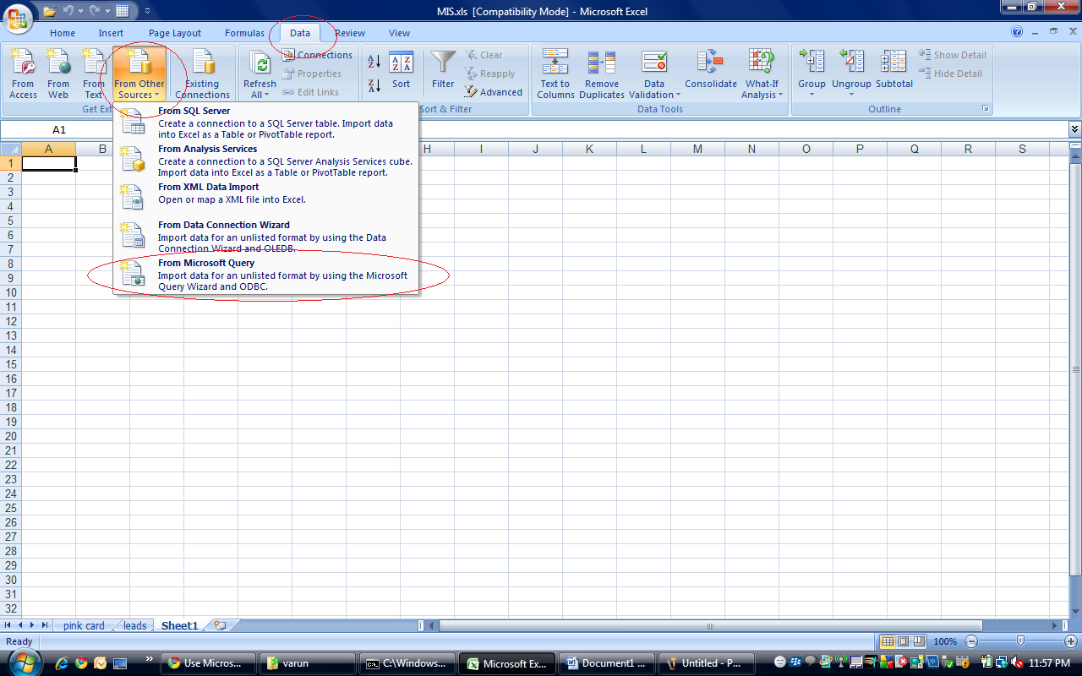

- In the Choose Data Source dialog box, make sure that the Use the Query Wizard to create/edit queries check box is selected.
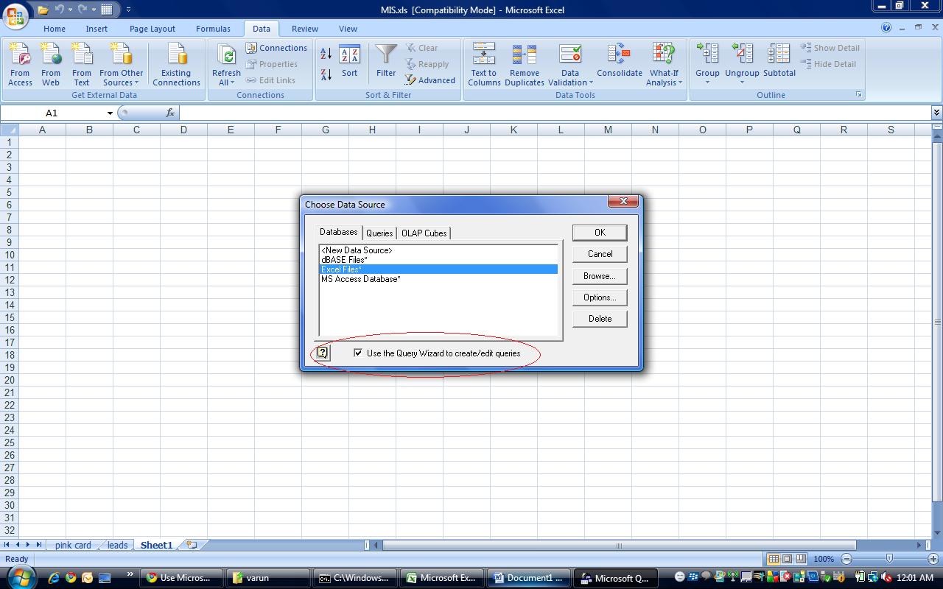

- Double-click the third option - Excel Files.
- A dialog opens up, asking for location of workbook. Browse to the location of pinkcards_mis.xls.
- Click Options and put a tick mark on System Tables.
- Select leads, click arrow head, & similarly select pink card, click arrow head.
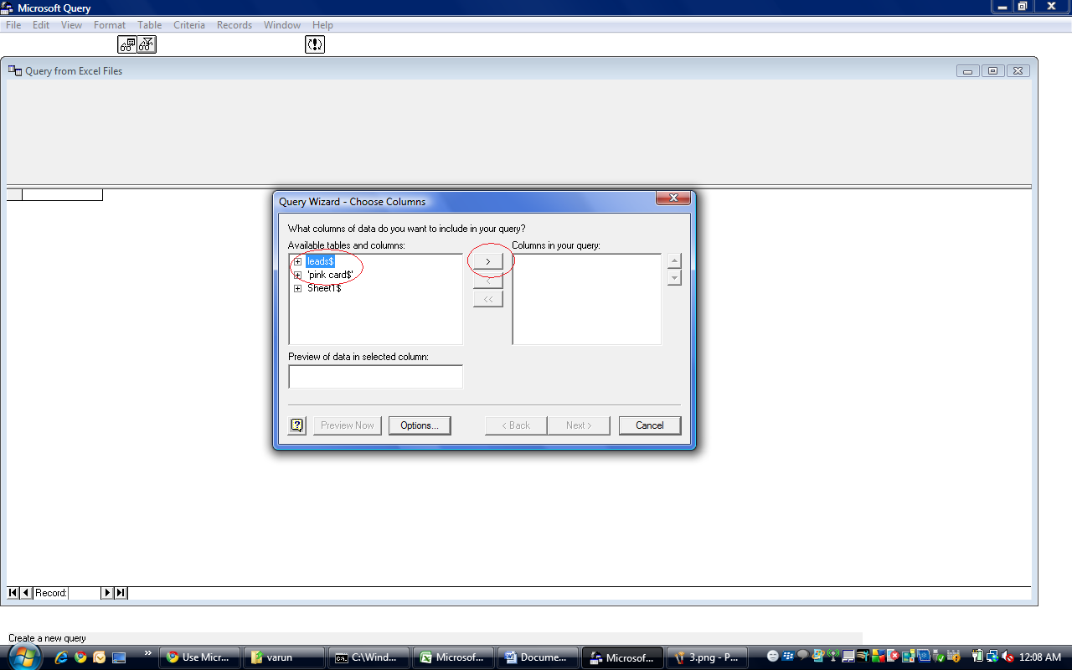
- Click Next.
- Click Ok.
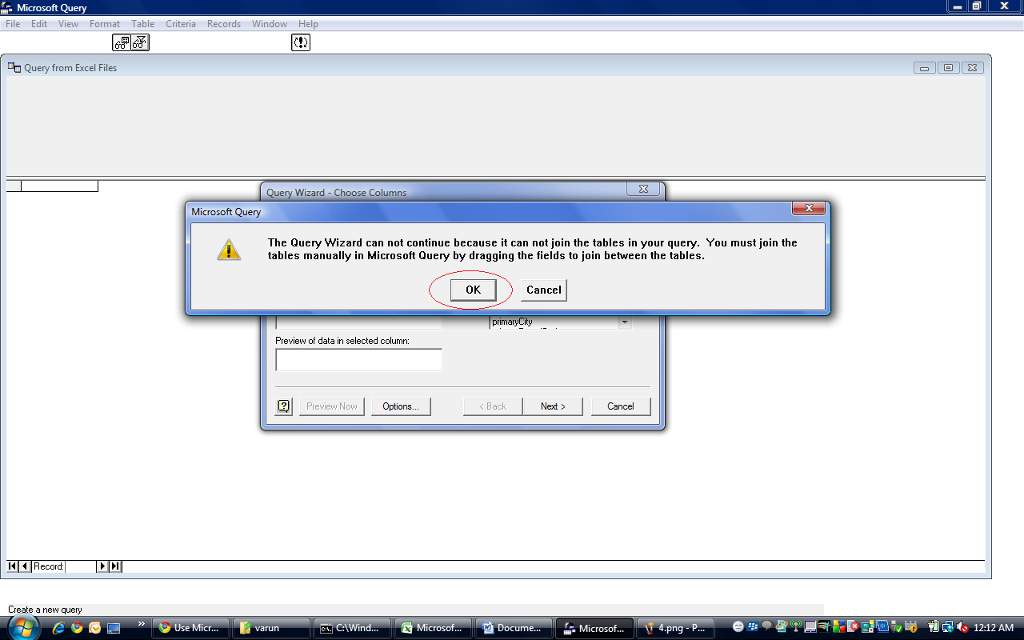
- Select and drag partyId (under leads) till leadPartyId (under pinkcard).
- Click Return Data to Microsoft Office Excel.
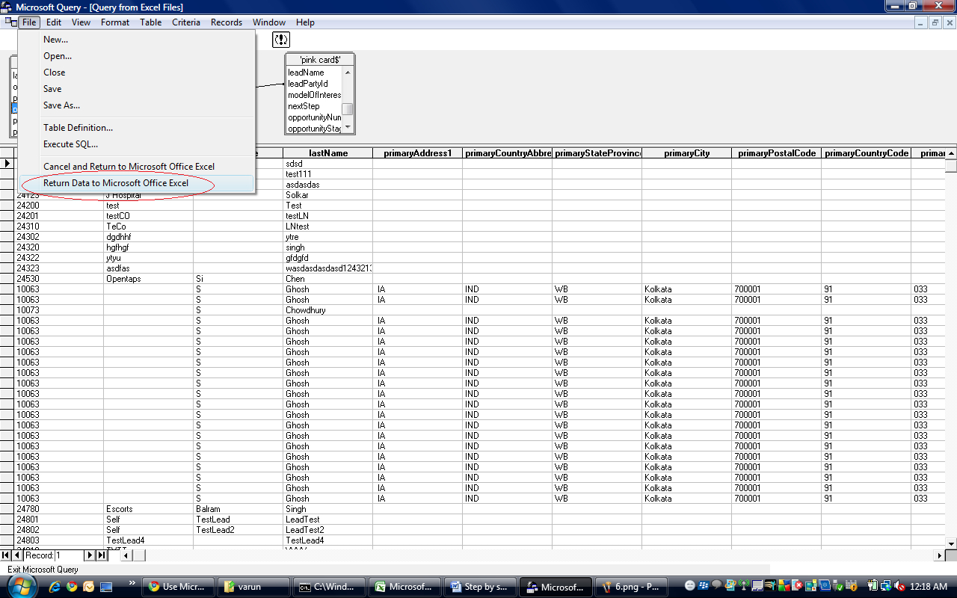
- Select Table, click Ok.
- The sheet now contains the cross linking between leads and pink cards.
- For further reference, you may refer http://office.microsoft.com/en-us/excel/HA100996641033.aspx

